**PROJECT REPORT TEMPLATED**

**ELECTRICITY** **CONSUMPTION PATTERN**

**1 INTRODUCTION**

**1.1 Overview**

India is the world's third-largest producer and third-largest consumer of electricity. The national electric grid in India has an installed capacity of 370.106 GW as of 31 March 2020. Renewable power plants, which also include large hydroelectric plants, constitute 35.86% of India's total installed capacity. During the fiscal year (FY) 2019–20, the total electricity generation in the country was 1,598 TWh , of which 1,383.5 TWh , generated by utilities. The gross electricity consumption per capita in FY2019 was 1,208 kWh. In 2015-16, electric energy consumption in agriculture was recorded as being the highest (17.89%) worldwide. The per capita electricity consumption is low compared to most other countries despite India having a low electricity tariff. In light of the recent COVID-19 situation, when everyone has been under lockdown for  
the months of March to June the impacts of the lockdown on economic activities have  
been faced by every sector in a positive or a negative way .The dataset is exhaustive in its demonstration of energy consumption state wise. Analysing Electricity Consumption in India from Jan 2019 till 5th December 2020. This dataset contains a record of Electricity consumption in each states of India, here we are going to analyse State wise Region wise and Overall Electricity consumption in India.

**1.2 PURPOSE**

Electric energy consumption is energy consumption in the form of electrical energy. About a fifth of global energy is consumed as electricity: for residential, industrial, commercial, transportation and other purposes. Quickly increasing this share by further electrification is extremely important to limit climate change ,because most other energy is consumed by burning fossil fuels thus emitting greenhouse gases which trap heat. Global electricity consumption in 2022 was 24,398 terawatt-hour (TWh), nearly three times the amount of consumption in 1981 (8,133 TWh). China, the United States, India and Japan accounted for more than half of the global share of electricity consumption.

Electric energy is most often measured either in joules (J), or in watt hours (W·h).

1 W·s = 1 J

1 W·h = 3600 W·s = 3600 J

Electric and electronic devices consume electric energy to generate desired output (light, heat, motion, etc.). During operation, some part of the energy is lost depending on the electrical efficiency.

Electric has been generated in power stations since 1882.The invention of the steam turbine in 1884 to drive the electric generator led to an increase in worldwide electricity consumption. In 2019, total worldwide electricity production was nearly 27,044 TWh. Total primary energy is converted into numerous forms, including, but not limited to, electricity, heat and motion .Some primary energy is lost during the conversion to electricity, as seen in the United States, where 61% was lost in 2019.

**2 PROBLEM DEFINITION AND DESIGN THINKING**

**2.1 EMPATHY MAP :**

* Essentially, an empathy map is a square divided into four quadrants with the user or client in the middle. Each of the four quadrants comprises a category that helps us delve into the mind of the user. The four empathy map quadrants look at what the user says, thinks, feels, and does.

**Definition:** An empathy map is a collaborative visualization used to articulate what we know about a particular type of user. It externalizes knowledge about users in order to

1) create a shared understanding of user needs, and 2) aid in decision making.

**How to Build an Empathy Map:**

* Define scope and goals
* Gather materials
* Collect research
* Individually generate sticky notes for each quadrant
* Converge to cluster and synthesize
* Polish and plan

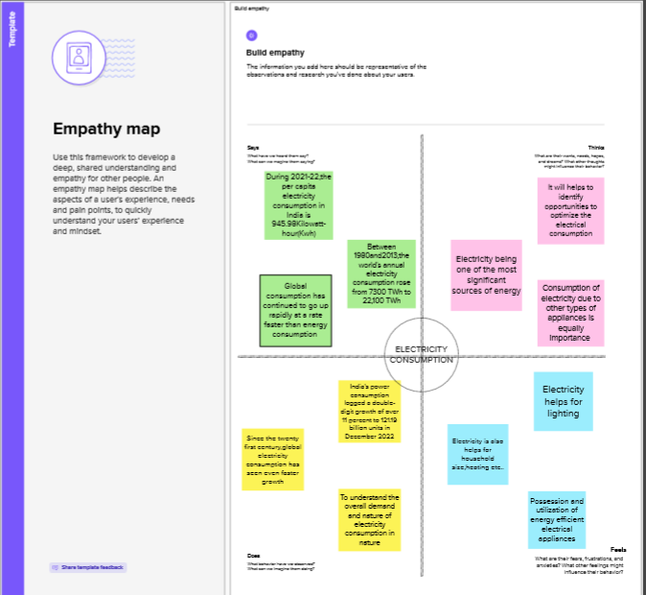 **2.2 IDEATION & BRAIN STROMING MAP :**

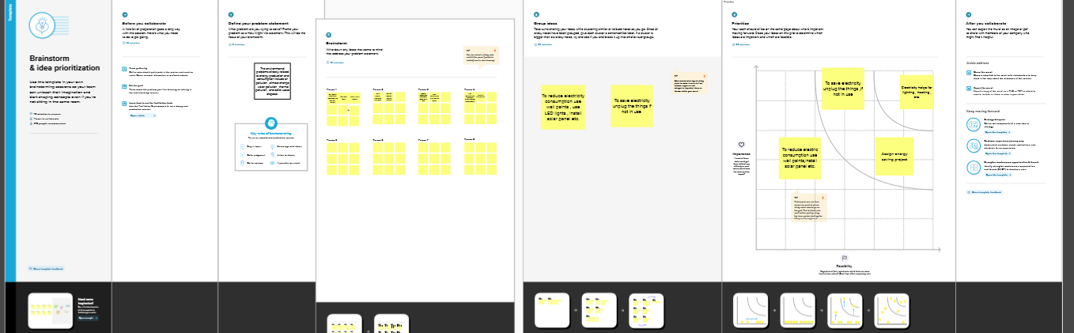

**3 RESULT**

**OUTPUT OF THE PROJECT :**

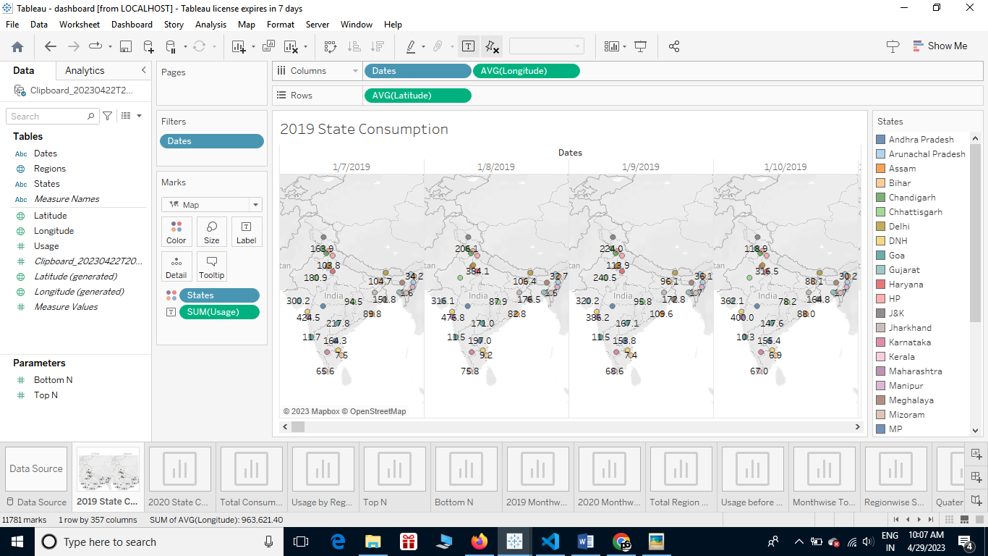 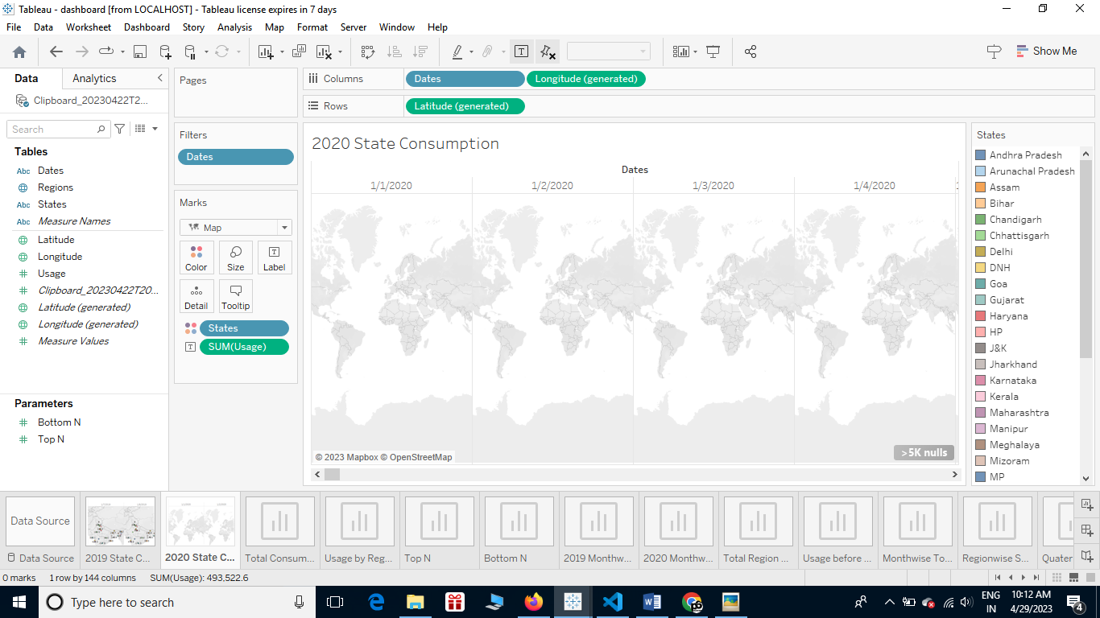

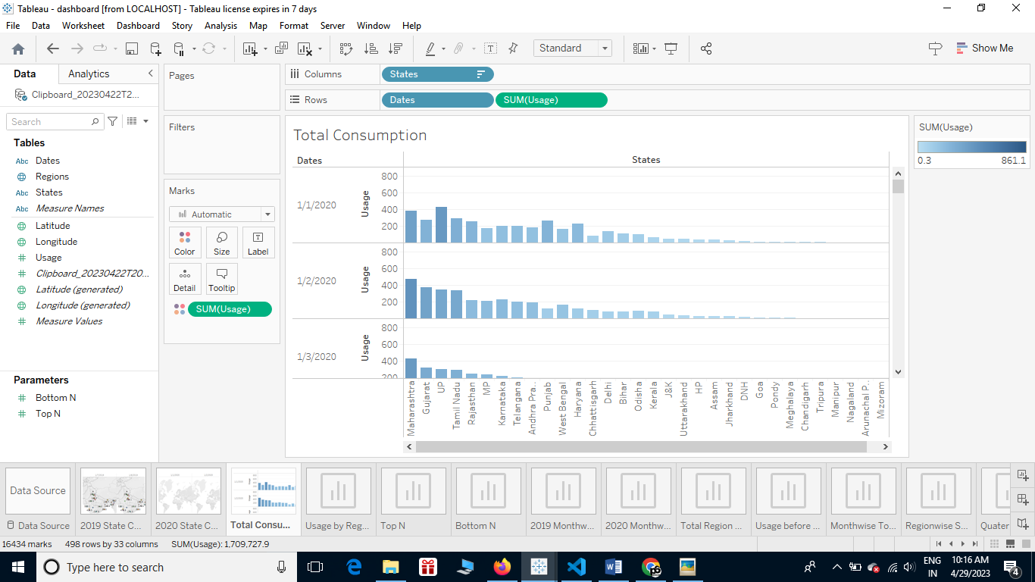

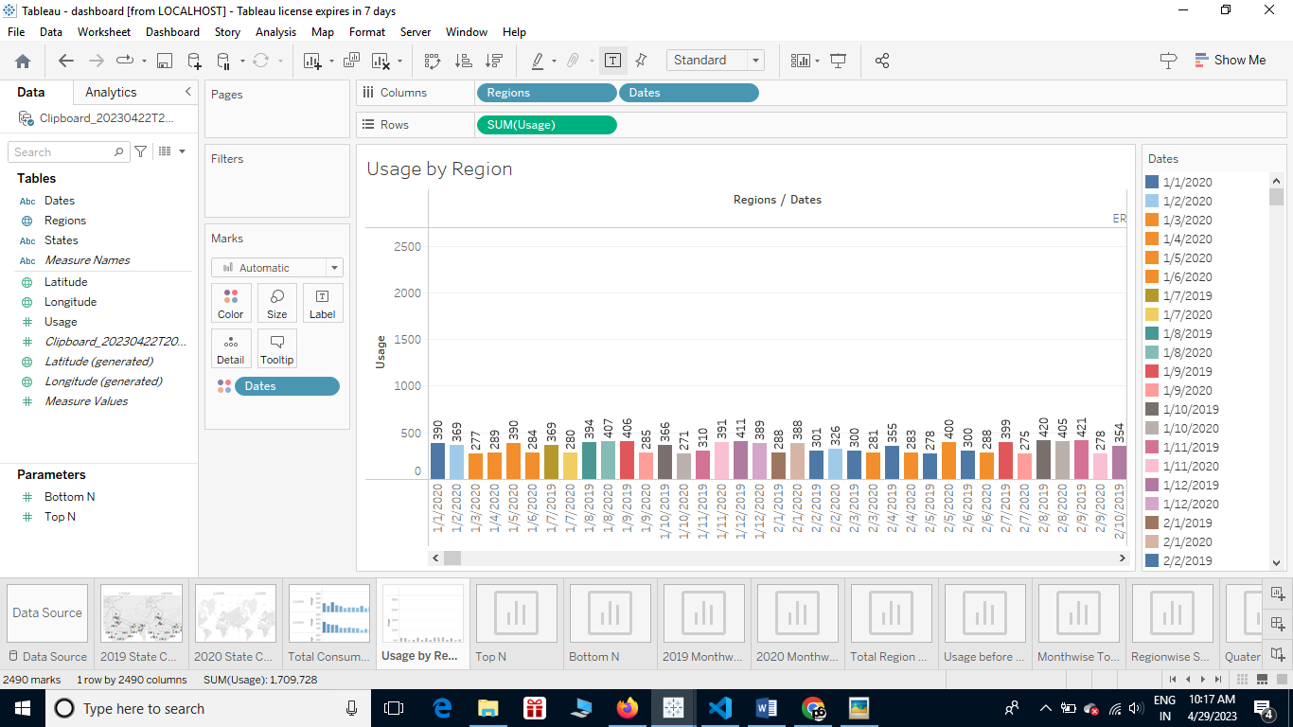

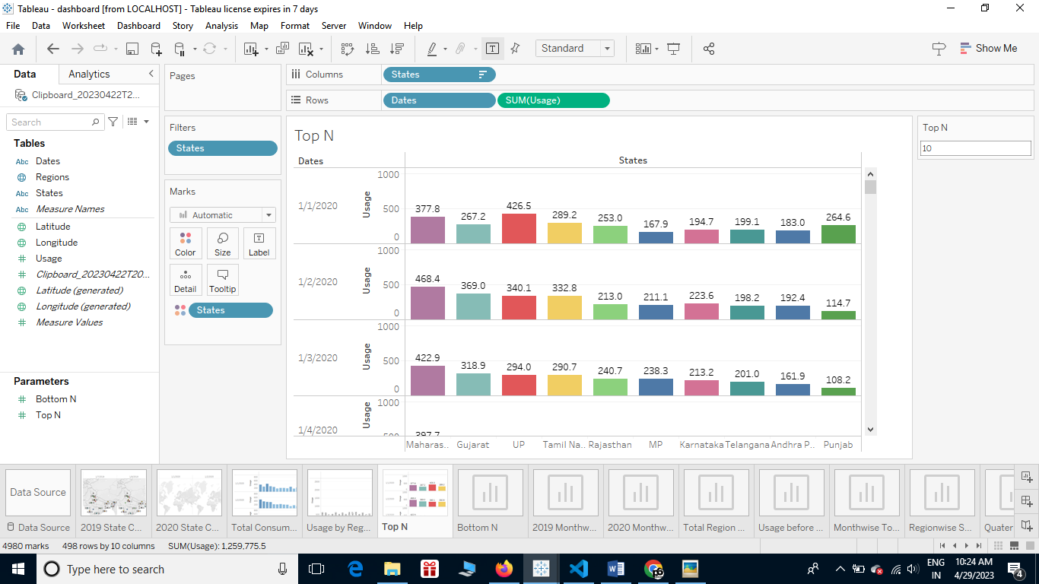

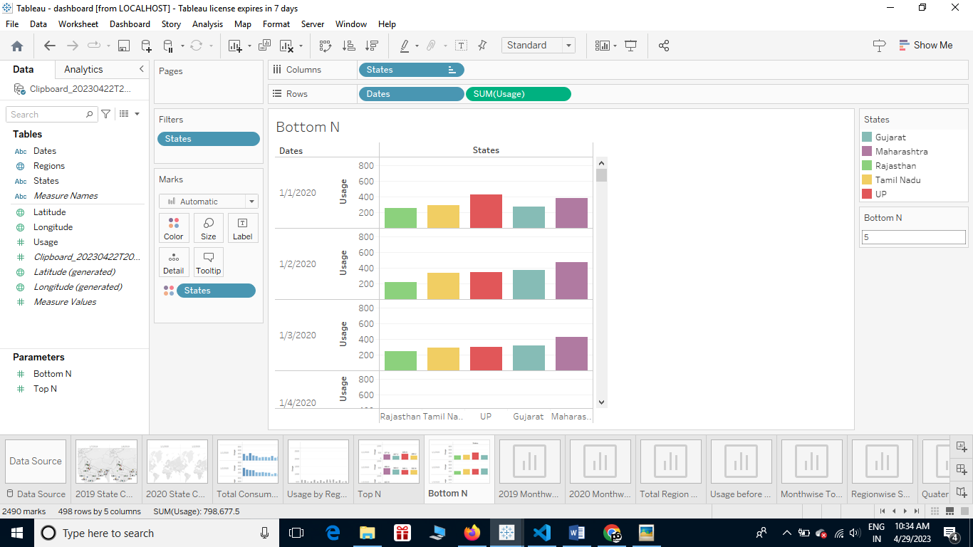

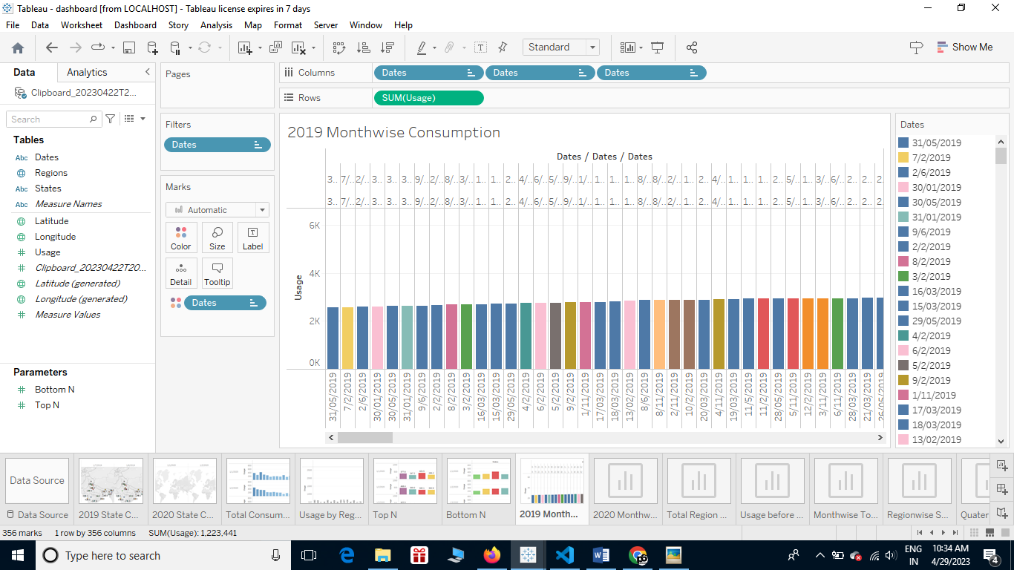

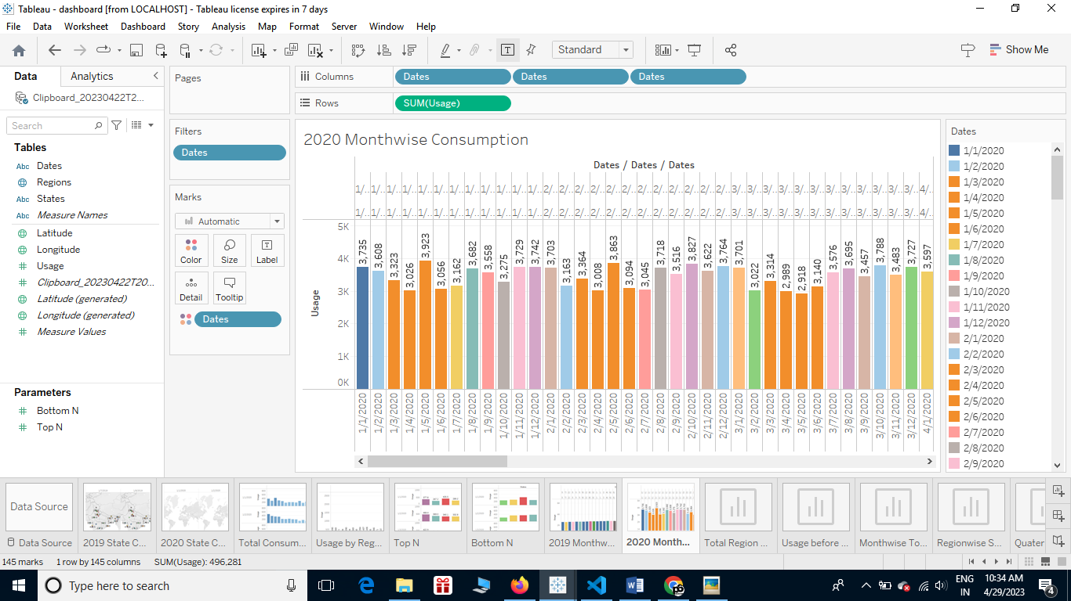

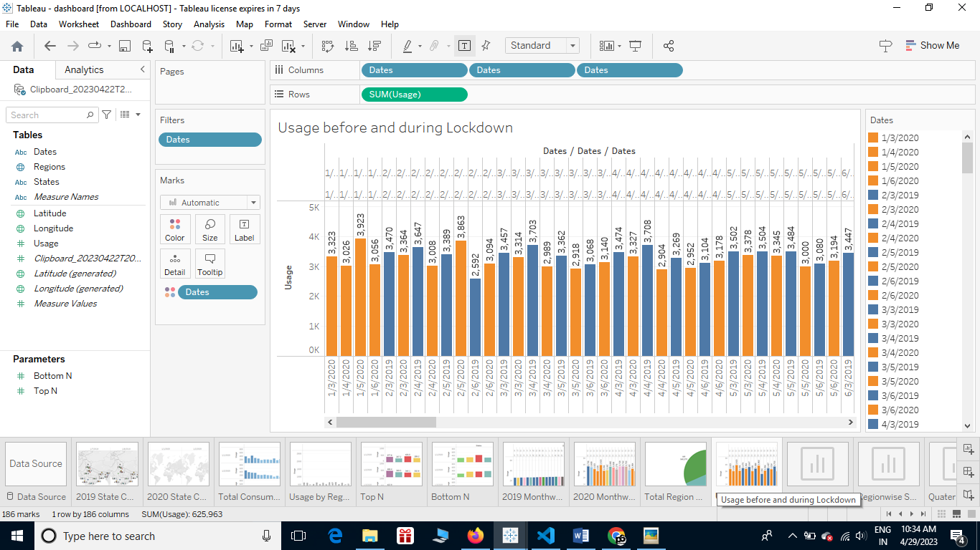

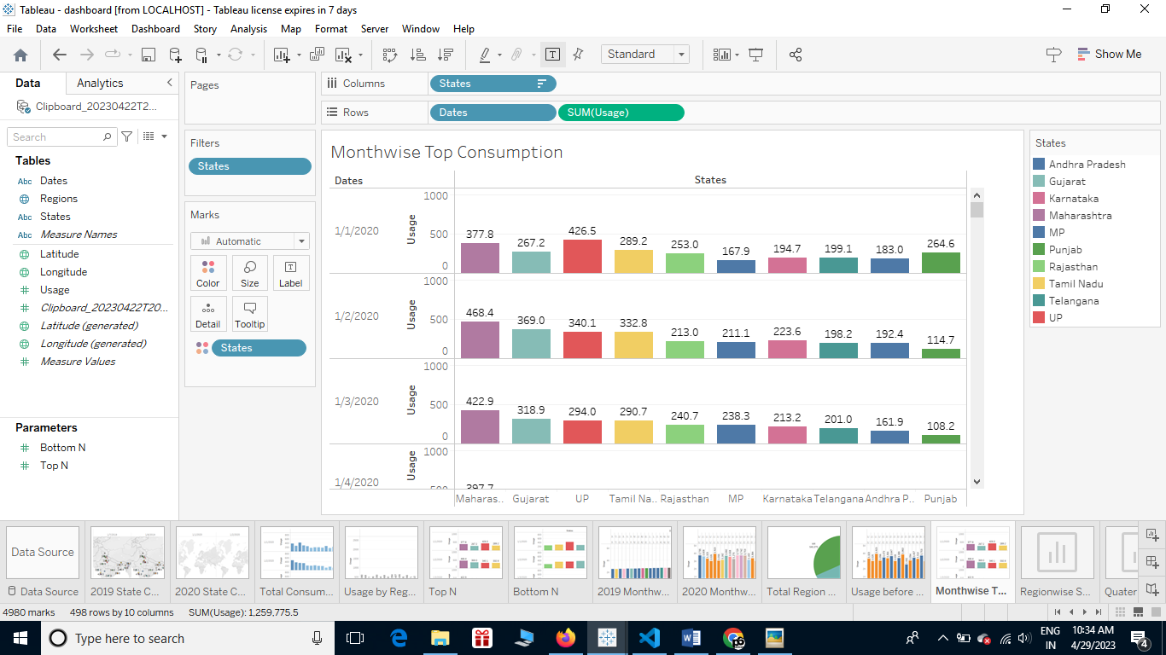

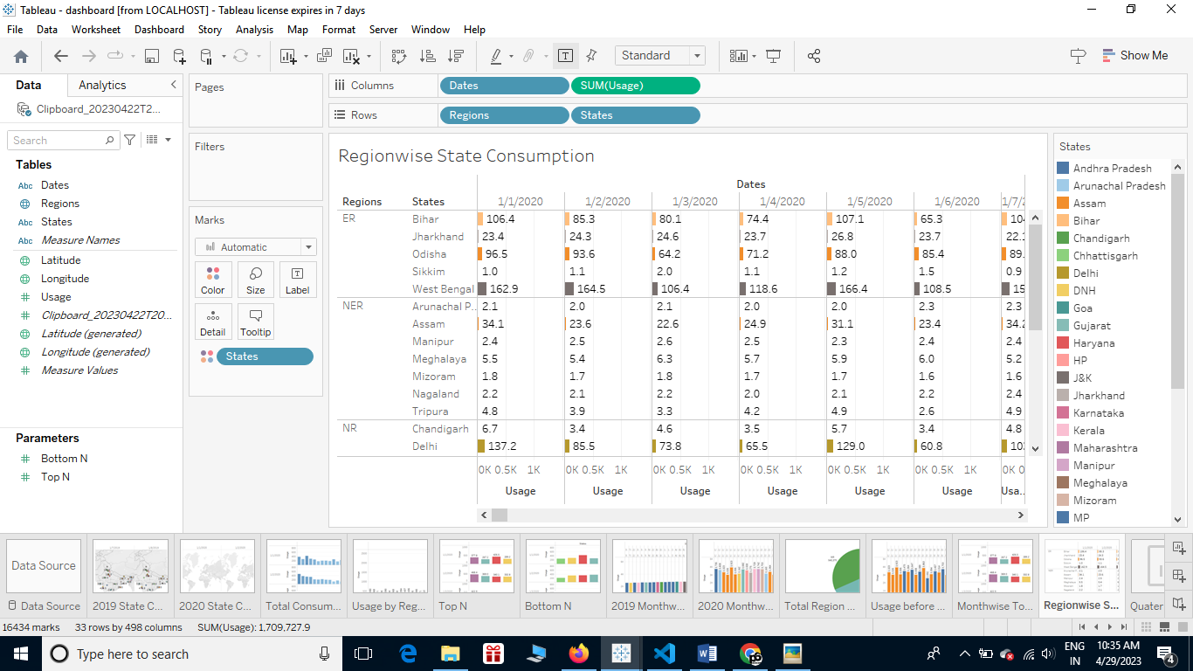

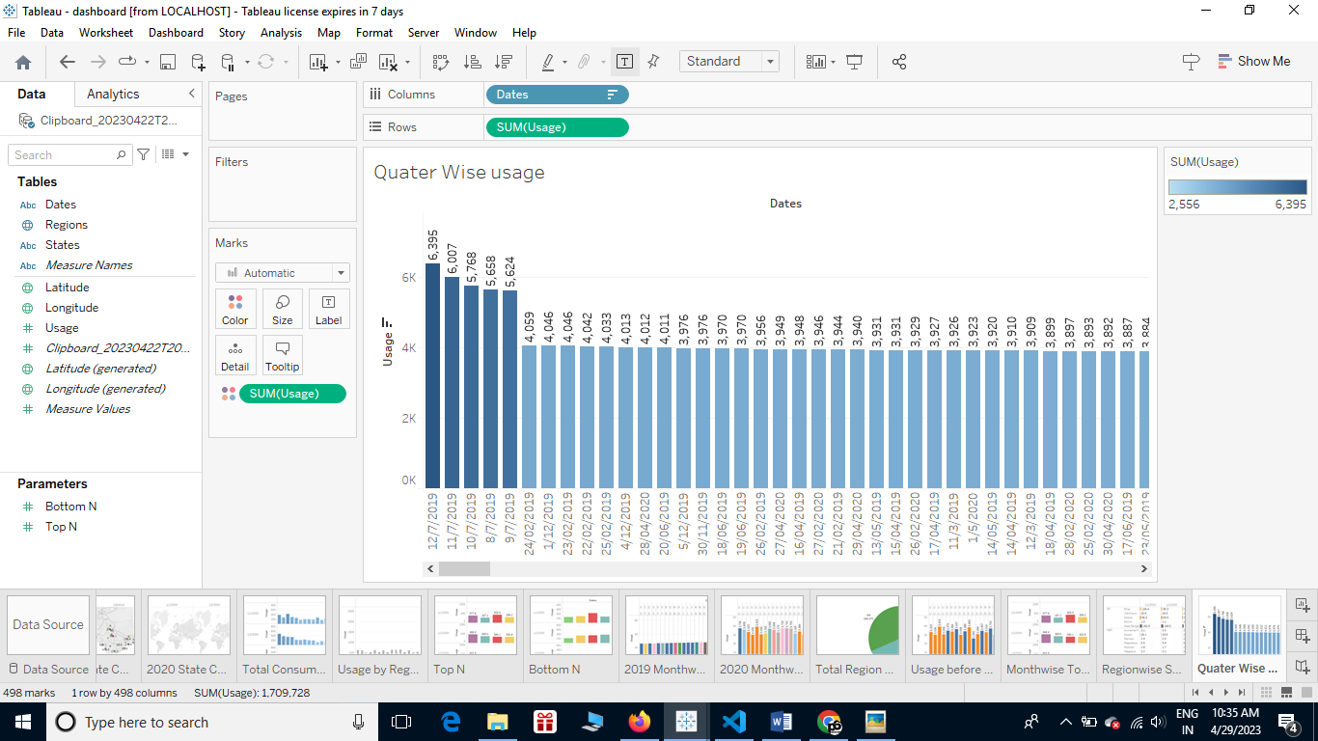

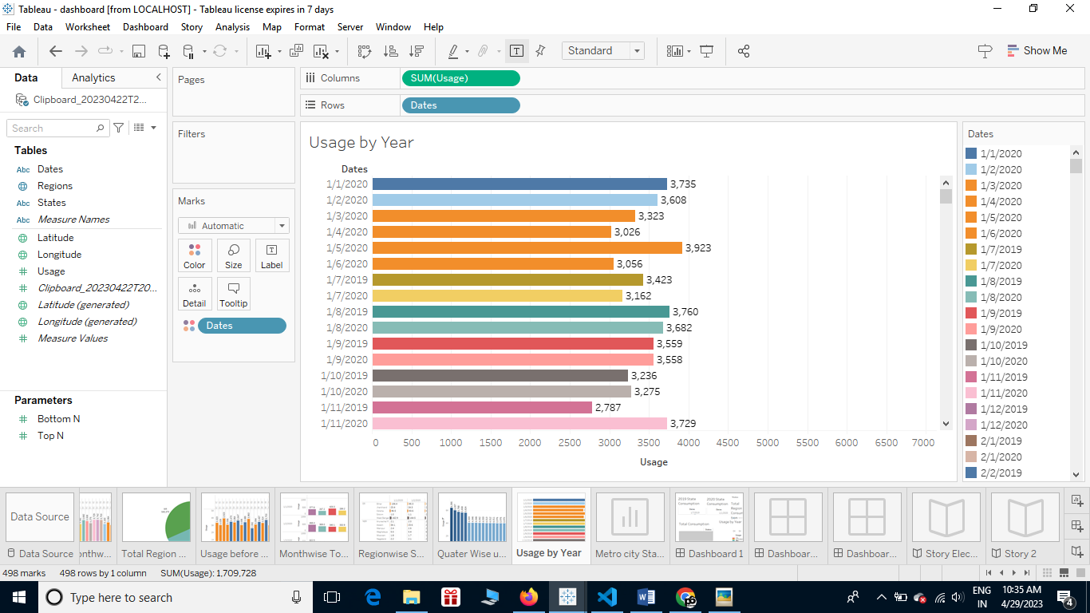

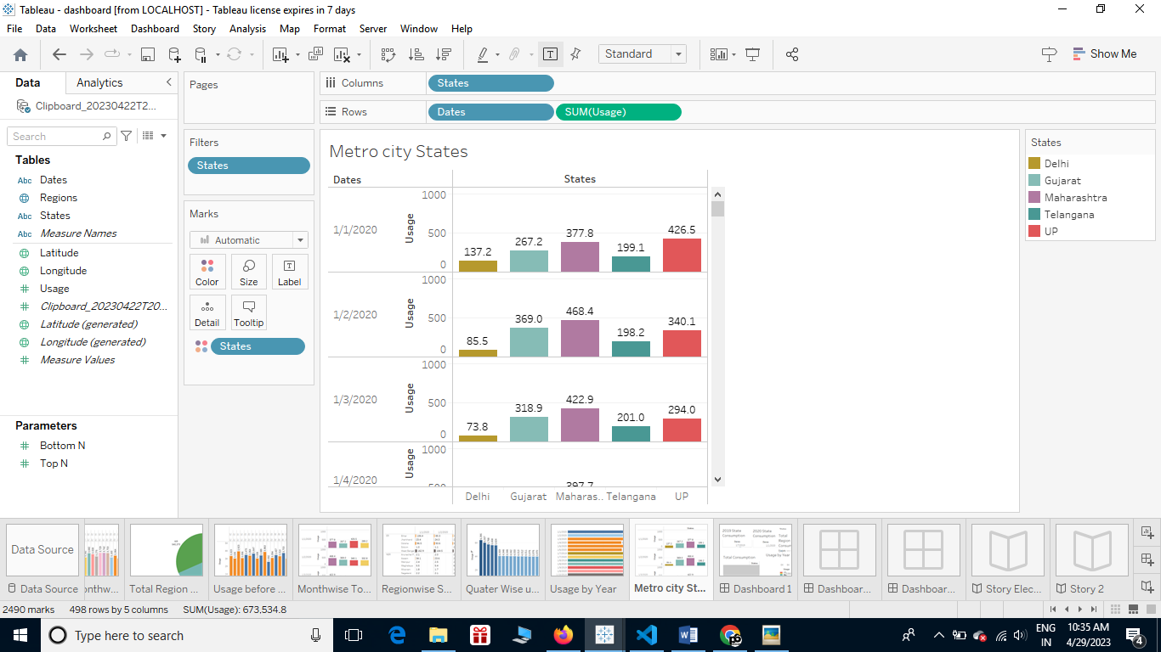

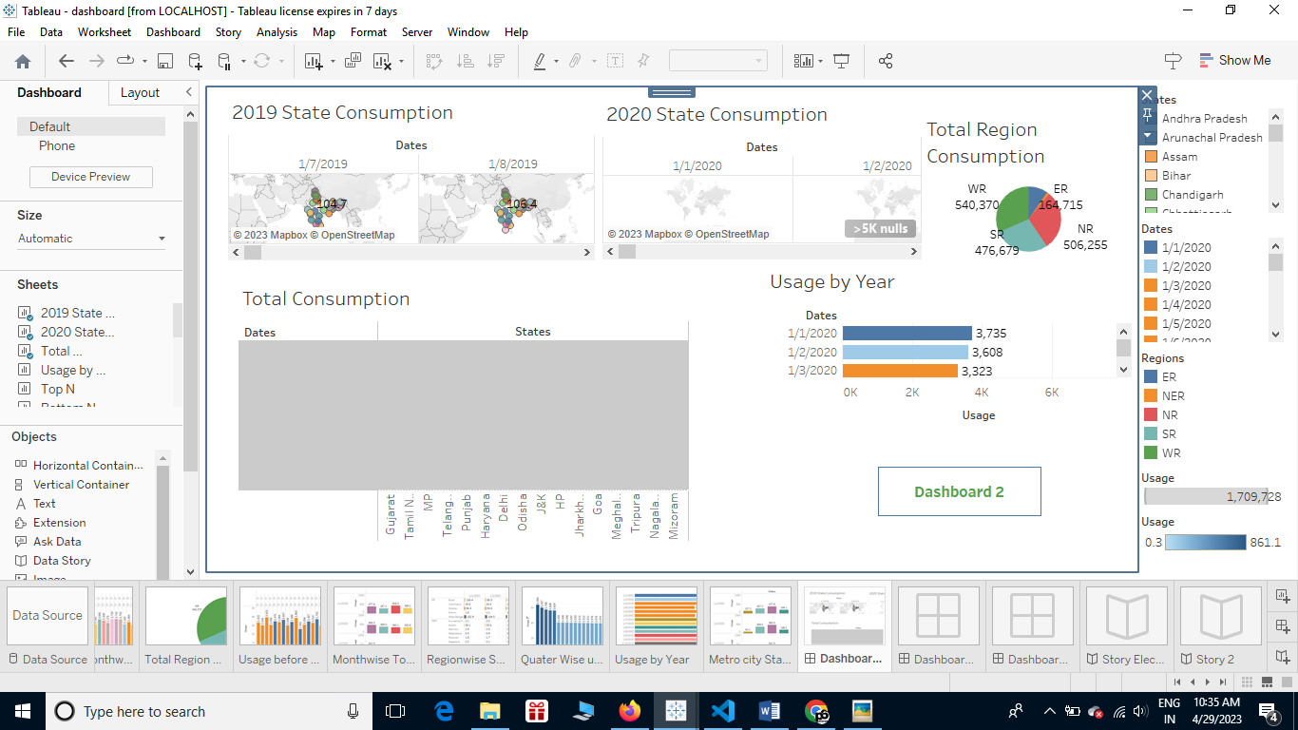

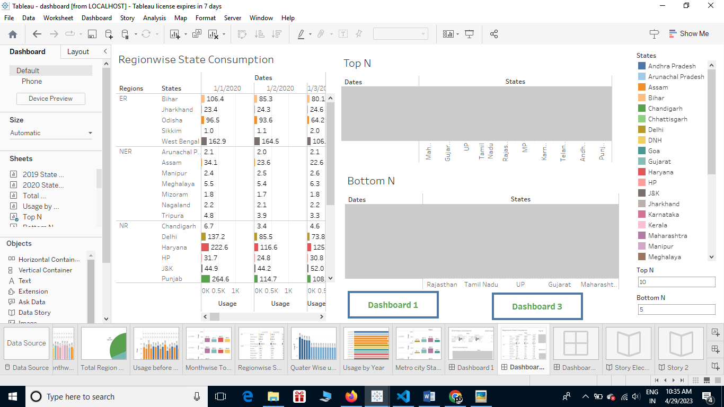

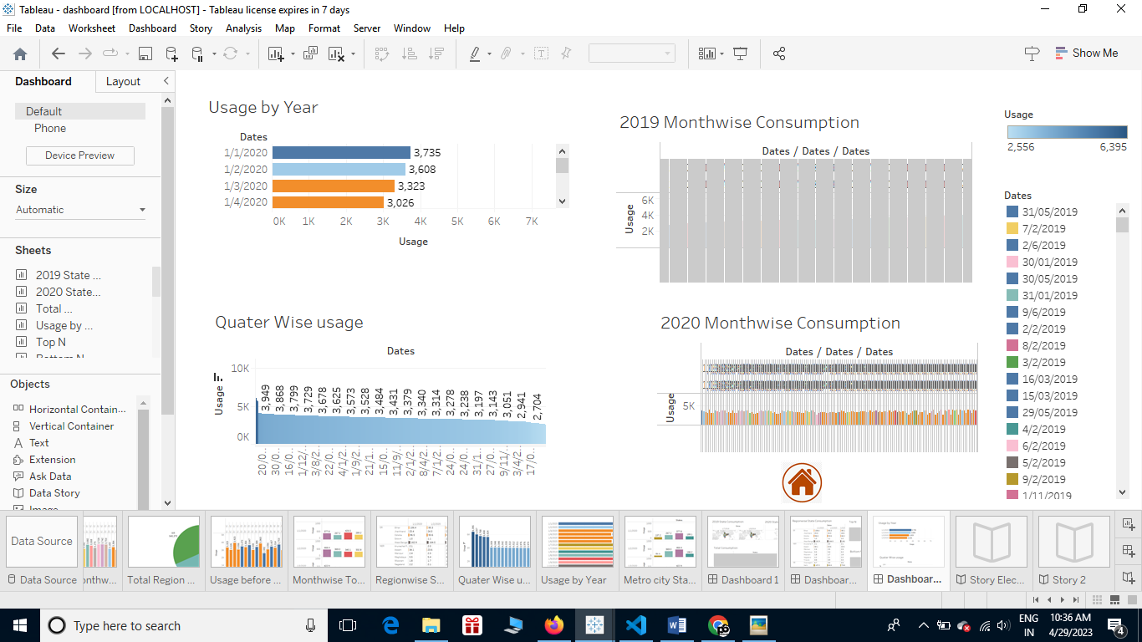

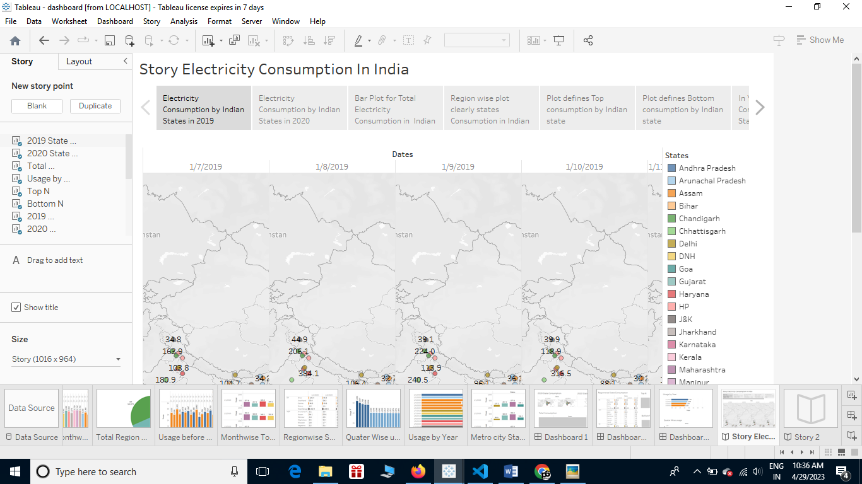

**4 ADVANTAGES & DISADVANTAGES :**

**ADVANTAGES :**

* It is a clean, safe, cheap and convenient source of energy.
* Lower maintenance cost.
* More efficient.
* No tailpipe emission.
* We all know that it  can be set up in many sizes.
* It doesn't require as many employees.
* Reduces greenhouse emission.
* Makes barely any pollution compare to other ways of creating or generating electricity.
* Relatively low maintenance cost.
* Hydroelectric station are inexpensive to operate.
* Hydroelectricity produces no gas emissions or waste.
* A station can operate and run for long periods of time.
* It is renewable.

**DISADVANTAGES** :

* More expensive than gasoline.
* Loss of fish species.
* Dependent on precipitation.
* Damming can cause loss of land suitable for agriculture as well as recreation.
* Cost for construction.
* Change in river or stream quality.
* An electric vehicle is not completely emission free.
* In electricity, there are a limited number of feasible sites for a large number of dams.
* Drought can affect power production.

**5 APPLICATION :**

* Electricity is an essential part of modern life and important to the U.S. economy. People use electricity for lighting, heating, cooling, and refrigeration and for operating appliances, computers, electronics, machinery, and public transportation systems. Total U.S. electricity consumption in 2022 was about 4.05 trillion kWh, the highest amount recorded and 14 times greater than electricity use in 1950. Total annual U.S. electricity consumption increased in all but 11 years between 1950 and 2022, and 8 of the years with year-over-year decreases occurred after 2007.
* Total electricity end-use consumption includes retail sales of electricity to consumers and *direct use* electricity. Direct use electricity is used by the same industrial or commercial sector facility where it is produced. The industrial sector accounts for most direct use electricity. Total direct use of electricity by the industrial and commercial sectors was about 3% of total electricity end-use consumption in 2022.
* Total U.S. electricity end-use consumption in 2022 was about 2.6% higher than in 2021. In 2022, retail electricity sales to the residential sector were about 3.5% higher than in 2021, and retail electricity sales to the commercial sector were about 3.4% higher than in 2021. Electricity retail sales to the industrial sector in 2022 were about 0.7% higher than in 2021 but were about 5.3% lower than in 2000, the year of highest U.S. retail sales to the industrial sector. The industrial sector's percentage share of total U.S. electricity retail sales was about 31% in 2000 and 26% in 2022.

**6 CONCLUSION :**

Electricity is the backbone of modern society. Our life will go back to the primitive age without electricity. There is a need for rational use of electricity, as it is largely produced from non-renewable sources like coal and water. Alternative sources of electricity should be explored to meet the gap between its demand and supply. We should take every step to conserve sources of electricity for future generations.

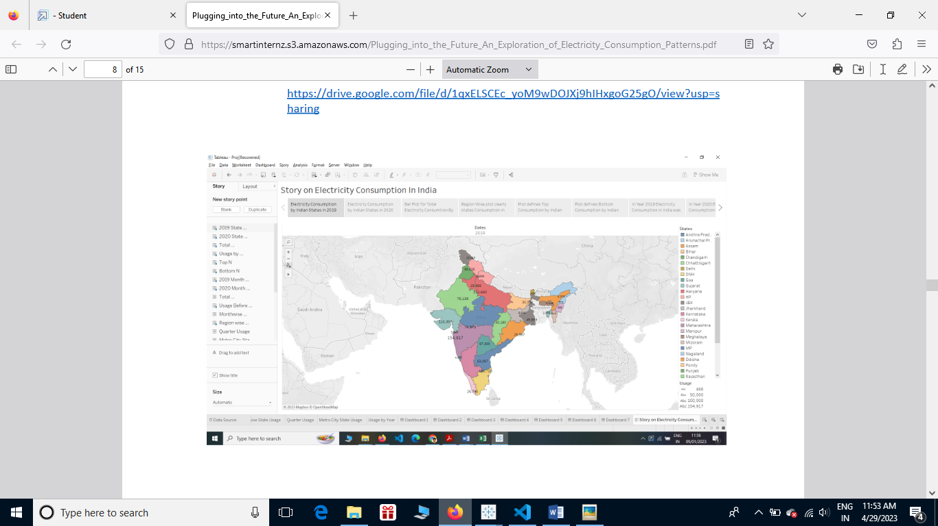

**7 FUTURE SCOPE :**

In the Stated Policies Scenario, global electricity demand grows at 2.1% per year to 2040, twice the rate of primary energy demand. This raises electricity’s share in total final energy consumption from 19% in 2018 to 24% in 2040. Electricity demand growth is set to be particularly strong in developing economies. Government policies, market conditions and available technologies collectively set a course for electricity supply to shift towards low-carbon sources, with their share increasing from 36% today to 52% in 2040 in the Stated Policies Scenario.

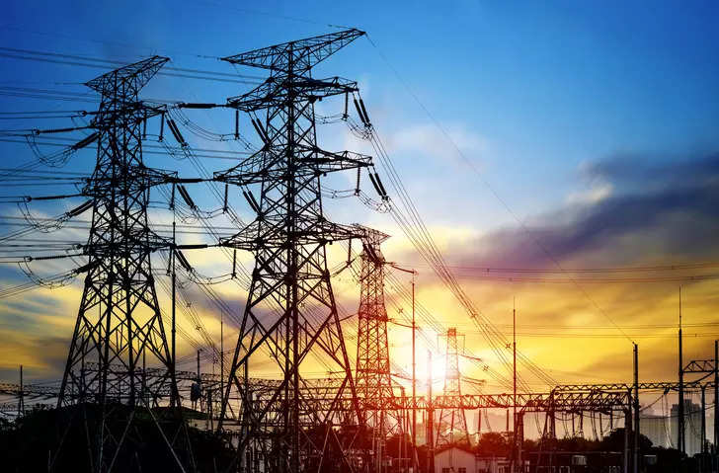

**8 APPENDIX**

**A.SOURCE CODE**

**DASHBOARD**

<DOCTYPE html>

<html lang="en">

<head>

    <meta charset="UTF-8">

    <meta http-equiv="X-UA-Compatible" content="IE=edge">

    <meta name="viewport" content="width=device-width,initial-scale=1.0">

    <title>Document</title>

</head>

<body>

</body>

<div class='tableauPlaceholder' id='viz1682668034296' style='position: relative'><noscript><a href='#'><img alt='Dashboard 1 ' src='https:&#47;&#47;public.tableau.com&#47;static&#47;images&#47;da&#47;dashboard_16826676129100&#47;Dashboard1&#47;1_rss.png' style='border: none' /></a></noscript><object class='tableauViz'  style='display:none;'><param name='host_url' value='https%3A%2F%2Fpublic.tableau.com%2F' /> <param name='embed_code_version' value='3' /> <param name='site_root' value='' /><param name='name' value='dashboard_16826676129100&#47;Dashboard1' /><param name='tabs' value='no' /><param name='toolbar' value='yes' /><param name='static_image' value='https:&#47;&#47;public.tableau.com&#47;static&#47;images&#47;da&#47;dashboard_16826676129100&#47;Dashboard1&#47;1.png' /> <param name='animate_transition' value='yes' /><param name='display_static_image' value='yes' /><param name='display_spinner' value='yes' /><param name='display_overlay' value='yes' /><param name='display_count' value='yes' /><param name='language' value='en-US' /><param name='filter' value='publish=yes' /></object></div>                <script type='text/javascript'>                    var divElement = document.getElementById('viz1682668034296');                    var vizElement = divElement.getElementsByTagName('object')[0];                    if ( divElement.offsetWidth > 800 ) { vizElement.style.width='100%';vizElement.style.height=(divElement.offsetWidth*0.75)+'px';} else if ( divElement.offsetWidth > 500 ) { vizElement.style.width='100%';vizElement.style.height=(divElement.offsetWidth*0.75)+'px';} else { vizElement.style.width='100%';vizElement.style.height='1827px';}                     var scriptElement = document.createElement('script');                    scriptElement.src = 'https://public.tableau.com/javascripts/api/viz_v1.js';                    vizElement.parentNode.insertBefore(scriptElement, vizElement);                </script>

</html>

**STORY**

<DOCTYPE html>

<html lang="en">

<head>

    <meta charset="UTF-8">

    <meta http-equiv="X-UA-Compatible" content="IE=edge">

    <meta name="viewport" content="width=device-width,initial-scale=1.0">

    <title>Document</title>

</head>

<body>

</body>

<div class='tableauPlaceholder' id='viz1682671788335' style='position: relative'><noscript><a href='#'><img alt='Story Electricity Consumption In India ' src='https:&#47;&#47;public.tableau.com&#47;static&#47;images&#47;st&#47;story_16826597092970&#47;StoryElectricityConsumptionInIndia&#47;1_rss.png' style='border: none' /></a></noscript><object class='tableauViz'  style='display:none;'><param name='host_url' value='https%3A%2F%2Fpublic.tableau.com%2F' /> <param name='embed_code_version' value='3' /> <param name='site_root' value='' /><param name='name' value='story_16826597092970&#47;StoryElectricityConsumptionInIndia' /><param name='tabs' value='no' /><param name='toolbar' value='yes' /><param name='static_image' value='https:&#47;&#47;public.tableau.com&#47;static&#47;images&#47;st&#47;story_16826597092970&#47;StoryElectricityConsumptionInIndia&#47;1.png' /> <param name='animate_transition' value='yes' /><param name='display_static_image' value='yes' /><param name='display_spinner' value='yes' /><param name='display_overlay' value='yes' /><param name='display_count' value='yes' /><param name='language' value='en-US' /><param name='filter' value='publish=yes' /></object></div>                <script type='text/javascript'>                    var divElement = document.getElementById('viz1682671788335');                    var vizElement = divElement.getElementsByTagName('object')[0];                    vizElement.style.width='1016px';vizElement.style.height='991px';                    var scriptElement = document.createElement('script');                    scriptElement.src = 'https://public.tableau.com/javascripts/api/viz_v1.js';                    vizElement.parentNode.insertBefore(scriptElement, vizElement);                </script>

</html>